**CMPSC473 Project4 Performance Evaluation (proj4-tujb)**

**By: Joseph Brauckmann and Taylan Unal**

**SUMMARY:**

Through this project, we gained hands-on experience working directly with threads, implementing concurrency, and ensuring data integrity within the program. We extended the original single-threaded program to allow for concurrent processing by implementing mutex locking/unlocking and thread signaling to ensure data integrity.

After completing and passing all the tests provided within test.py, we analyzed the performance of our wordcount application by running tests on a custom input file with sample text. We found through our testing that there is a clear trade off of program run-time when implemented in a “thread-safe” manner.

After running Tests 1-6 with each subsequent test doubling the number of threads to run the program with, while keeping the buffer size the same at 1000 bytes, we found a linear relationship between number of threads and average real completion time. We believe that the reason for this increase in completion time has to do with the time to handle locking/unlocking, creating/sending wait conditions and signals for each thread.

After running Tests 7-9, we found a surprising trend: that the increase in buffer size from 100 bytes to 10,000 bytes, while maintaining 8 threads, had no impact on the average real completion time of the program. We believe that buffer size had no real impact on completion time because the major time components of the map-reduce wordcount application were the mapper and the reducer phases, which depended heavily upon the threads that run the application.

# TEST RESULTS:

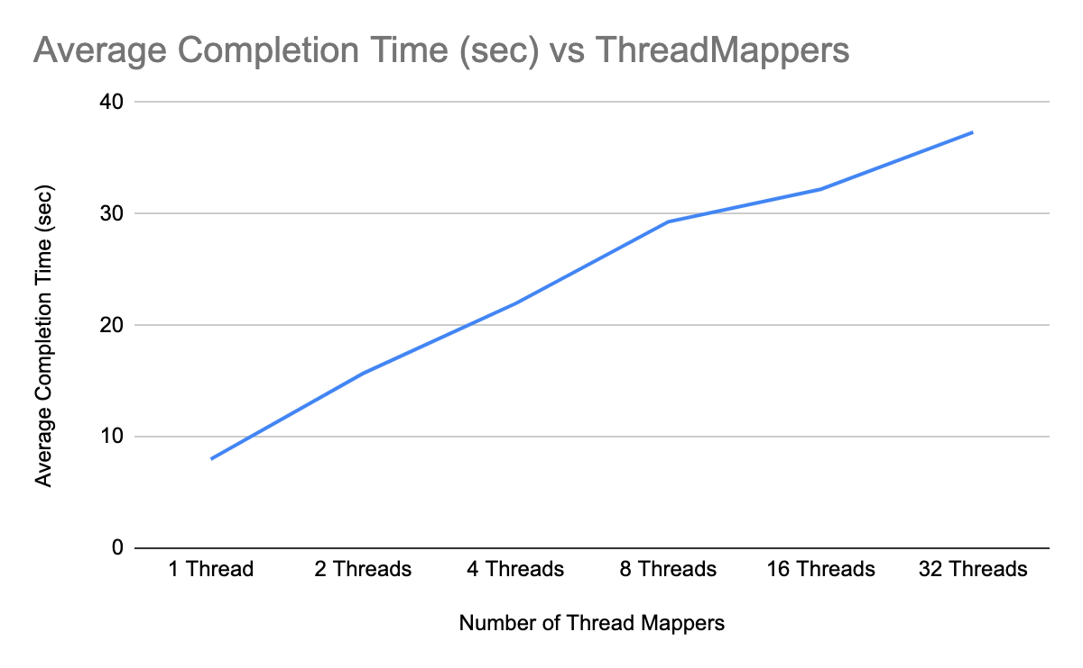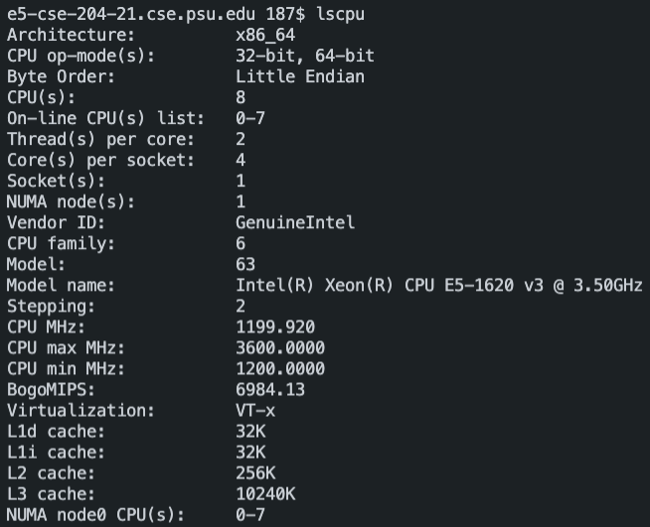

**@TEST1 (RUN 5x)**

/usr/bin/time -f "Real time in sec is %e" ./wordcount custom_eval 1 1000 perf_eval.txt perf_out.txt

TEST NAME Real Time to Complete

|  |  |
| --- | --- |
| Test1 [Threads: 1, Buffer Size: 1000B] | 7.71s |
| Test1 [Threads: 1, Buffer Size: 1000B] | 7.75s |
| Test1 [Threads: 1, Buffer Size: 1000B] | 7.78s |
| Test1 [Threads: 1, Buffer Size: 1000B] | 7.60s |
| Test1 [Threads: 1, Buffer Size: 1000B] | 9.12s |

**AVERAGE TIME (in seconds):** 7.992s

**AVERAGE TIME (in microseconds):** 7992000μs

**MINIMUM TIME (in microseconds):** 7600000μs

**@TEST2 (RUN 5x)**

/usr/bin/time -f "Real time in sec is %e" ./wordcount custom_eval 2 1000 perf_eval.txt perf_out.txt

TEST NAME Real Time to Complete

|  |  |
| --- | --- |
| Test2 [Threads: 2, Buffer Size: 1000B] | 15.71s |
| Test2 [Threads: 2, Buffer Size: 1000B] | 18.96s |
| Test2 [Threads: 2, Buffer Size: 1000B] | 12.35s |
| Test2 [Threads: 2, Buffer Size: 1000B] | 15.28s |
| Test2 [Threads: 2, Buffer Size: 1000B] | 16.21s |

**AVERAGE TIME (in seconds):** 15.702s

**AVERAGE TIME (in microseconds):** 15702000μs

**MINIMUM TIME (in microseconds):** 12350000μs

**@TEST3 (RUN 5x)**

/usr/bin/time -f "Real time in sec is %e" ./wordcount custom_eval 4 1000 perf_eval.txt perf_out.txt

TEST NAME Real Time to Complete

|  |  |
| --- | --- |
| Test3 [Threads: 4, Buffer Size: 1000B] | 21.11s |
| Test3 [Threads: 4, Buffer Size: 1000B] | 19.71s |
| Test3 [Threads: 4, Buffer Size: 1000B] | 23.85s |
| Test3 [Threads: 4, Buffer Size: 1000B] | 21.78s |
| Test3 [Threads: 4, Buffer Size: 1000B] | 23.37s |

**AVERAGE TIME (in seconds):** 21.964s

**AVERAGE TIME (in microseconds):** 21964000**μs**

**MINIMUM TIME (in microseconds):** 19710000us

**@TEST4 (RUN 5x)**

/usr/bin/time -f "Real time in sec is %e" ./wordcount custom_eval 8 1000 perf_eval.txt perf_out.txt

TEST NAME Real Time to Complete

|  |  |
| --- | --- |
| Test4 [Threads: 8, Buffer Size: 1000B] | 29.80s |
| Test4 [Threads: 8, Buffer Size: 1000B] | 29.28s |
| Test4 [Threads: 8, Buffer Size: 1000B] | 29.81s |
| Test4 [Threads: 8, Buffer Size: 1000B] | 29.17s |
| Test4 [Threads: 8, Buffer Size: 1000B] | 28.41s |

**AVERAGE TIME (in seconds):** 29.294s

**AVERAGE TIME (in microseconds):** 29294000μs

**MINIMUM TIME (in microseconds):** 28410000μs

**@TEST5 (RUN 5x)**

/usr/bin/time -f "Real time in sec is %e" ./wordcount custom_eval 16 1000 perf_eval.txt perf_out.txt

TEST NAME Real Time to Complete

|  |  |
| --- | --- |
| Test5 [Threads: 16, Buffer Size: 1000B] | 31.87s |
| Test5 [Threads: 16, Buffer Size: 1000B] | 32.33s |
| Test5 [Threads: 16, Buffer Size: 1000B] | 31.58s |
| Test5 [Threads: 16, Buffer Size: 1000B] | 33.08s |
| Test5 [Threads: 16, Buffer Size: 1000B] | 32.16s |

**AVERAGE TIME (in seconds):** 32.204s

**AVERAGE TIME (in microseconds):** 32204000μs

**MINIMUM TIME (in microseconds):** 31580000μs

**@TEST6 (RUN 5x)**

/usr/bin/time -f "Real time in sec is %e" ./wordcount custom_eval 32 1000 perf_eval.txt perf_out.txt

TEST NAME Real Time to Complete

|  |  |
| --- | --- |
| Test6 [Threads: 32, Buffer Size: 1000B] | 32.27s |
| Test6 [Threads: 32, Buffer Size: 1000B] | 32.46s |
| Test6 [Threads: 32, Buffer Size: 1000B] | 41.76s |
| Test6 [Threads: 32, Buffer Size: 1000B] | 40.07s |
| Test6 [Threads: 32, Buffer Size: 1000B] | 40.14s |

**AVERAGE TIME (in seconds):** 37.34s

**AVERAGE TIME (in microseconds):** 37340000μs

**MINIMUM TIME (in microseconds):** 32270000μs

**@TEST7 (RUN 5x)**

/usr/bin/time -f "Real time in sec is %e" ./wordcount custom_eval 8 100 perf_eval.txt perf_out.txt

TEST NAME Real Time to Complete

|  |  |
| --- | --- |
| Test7 [Threads: 8, Buffer Size: 100B] | 28.72s |
| Test7 [Threads: 8, Buffer Size: 100B] | 30.30s |
| Test7 [Threads: 8, Buffer Size: 100B] | 28.23s |
| Test7 [Threads: 8, Buffer Size: 100B] | 29.77s |
| Test7 [Threads: 8, Buffer Size: 100B] | 30.31s |

**AVERAGE TIME (in seconds):** 29.466s

**AVERAGE TIME (in microseconds):** 29466000μs

**MINIMUM TIME (in microseconds):** 28230000μs

**@TEST8 (RUN 5x)**

/usr/bin/time -f "Real time in sec is %e" ./wordcount custom_eval 8 1000 perf_eval.txt perf_out.txt

TEST NAME Real Time to Complete

|  |  |
| --- | --- |
| Test8 [Threads: 8, Buffer Size: 1000B] | 29.82s |
| Test8 [Threads: 8, Buffer Size: 1000B] | 30.09s |
| Test8 [Threads: 8, Buffer Size: 1000B] | 31.20s |
| Test8 [Threads: 8, Buffer Size: 1000B] | 30.33s |
| Test8 [Threads: 8, Buffer Size: 1000B] | 29.55s |

**AVERAGE TIME (in seconds):** 30.198s

**AVERAGE TIME (in microseconds):** 30198000μs

**MINIMUM TIME (in microseconds):** 29550000μs

**@TEST9 (RUN 5x)**

/usr/bin/time -f "Real time in sec is %e" ./wordcount custom_eval 8 10000 perf_eval.txt perf_out.txt

TEST NAME Real Time to Complete

|  |  |
| --- | --- |
| Test9 [Threads: 8, Buffer Size: 10000B] | 30.01s |
| Test9 [Threads: 8, Buffer Size: 10000B] | 30.48s |
| Test9 [Threads: 8, Buffer Size: 10000B] | 29.00s |
| Test9 [Threads: 8, Buffer Size: 10000B] | 30.48s |
| Test9 [Threads: 8, Buffer Size: 10000B] | 30.69s |

**AVERAGE TIME (in seconds):** 30.132s

**AVERAGE TIME (in microseconds):** 30132000us

**MINIMUM TIME (in microseconds):** 29000000us